Sushi Go! Project

Overview
The programmer will create the game Sushi Go! Sushi Go! can be found online and retails for around $12. You do not have to buy it, but it is highly suggested. You may learn how to play the game by watching the How to play Sushi Go - Game Point video. Here are the rules to Sushi Go! You may create your own images or you may use the provided images.

Project Expectations

Number of players
The programmer has the option of making a 3, 4, or 5 player game of Sushi Go! The programmer may also create simple artificial intelligence for the game as extra credit.

The Contents
There are 108 total cards: 14 Tempura, 14 Sahimi, 14 Dumplings, 12 2-Maki rolls, 8 3-Maki rolls, 6 1-Maki roll, 10 Salmon Nigiri, 5 Squid Nigiri, 5 Egg Nigiri, 10 Puddings, 6 Wasabi, and 4 Chopsticks.

Preparing the Game
The game is played in three rounds, shuffle the cards and set them aside. Each round, deal the correct number of cards to each player depending on the number of players playing.

A Round
Each player will choose a card in their hand and place it face down in front of them. Then they pass the remaining cards to the left. All players simultaneously reveal their chosen card. Once all players are down to 2 cards, rather than passing to their left, they will discard the unwanted card. The round is over and the scoring begins, using the provided rules.
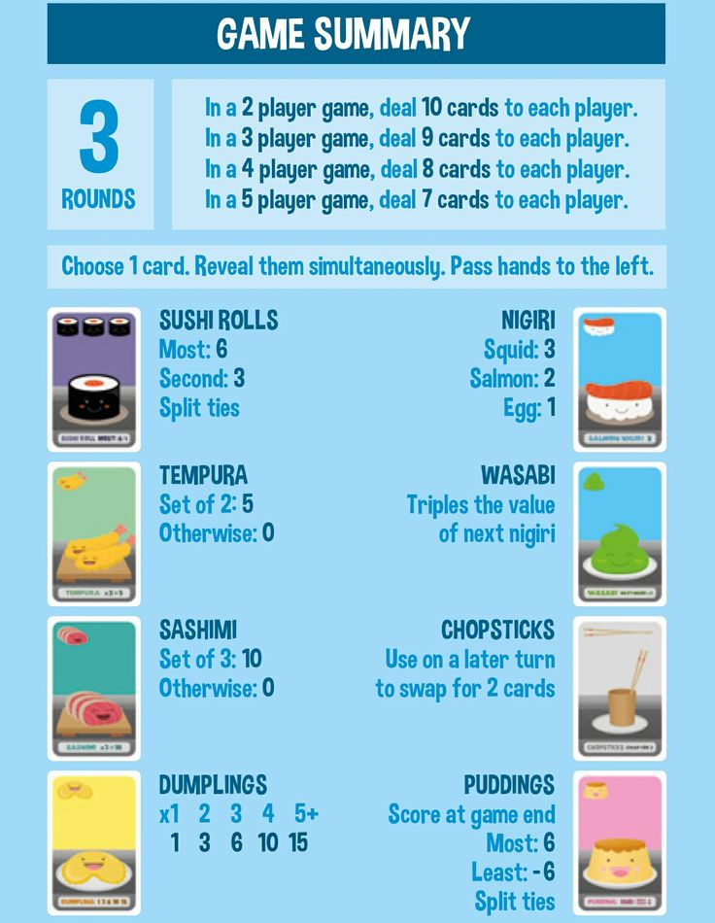
Ending the game
Once all three rounds are scored, add the pudding score and the winner is declared.

Here is a scoresheet that could help
